**General Sessions**

8:35-8:40am

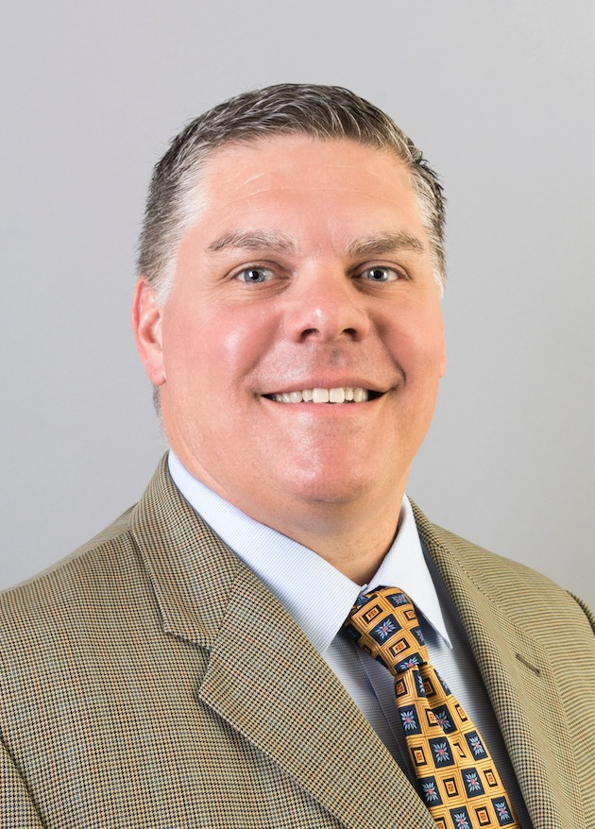

**Welcome Address & MC for the day! - Don Kurelich, VP- Strategic Products, Mentor**

8:40-9:20am

**Guest Keynote: Mouse McCoy, CEO/Co-Founder and Creative Director, Hackrod**



Mike "Mouse" McCoy is the CEO/Co-Founder and Creative Director of the Digital Industrial startup company Hackrod. Prior to founding Hackrod Mouse was the CEO of the award-winning Entertainment Studio Bandito Brothers. During his ten years at the Helm of Bandito Brothers he is most proud of architecting the unique branded entertainment model with the US Navy SEALs that led to the #1 box office Feature Film ‘Act of Valor’ which he produced and directed.

9:20-10:10am

***Layout suggestion for this session!***



**Fireside Chat: Mentor + Siemens**

**Tony Hemmelgarn, CEO, Siemens PLM Software**

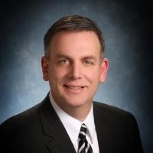

**Wally Rhines, CEO, Mentor Graphics**

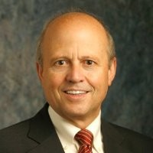

**Marcus Welz, CEO, Siemens ITS**

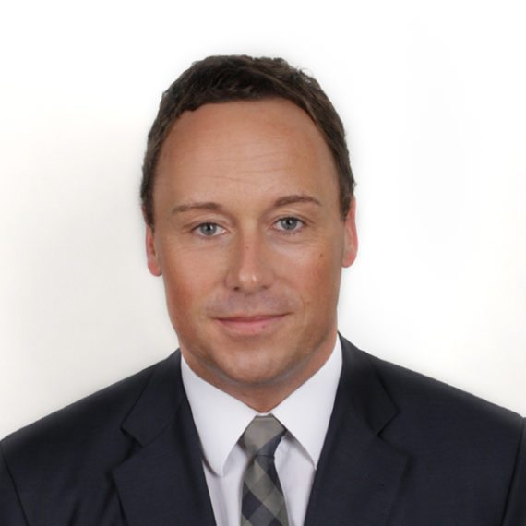

**Moderator: John McElroy, Host of TV Program, Autoline**

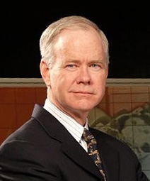

3:45-4:15pm

**Digital transformation of the mechatronics enterprise - Martin O’Brien, Vice President – Integrated Electrical Systems, Mentor**



We are living in a time of significant change and disruption of the automotive industry driven by exploding EE complexity coupled with electrification, autonomy, changing ownership preferences and many new-comer OEMS. The increasing digitalization of enterprises is one aspect of how organizations are looking to address some of these challenges.

4:15-4:45 pm

**The Hansen Report Live - Paul Hansen, The Hansen Report**



Paul Hansen, in his 10th appearance at IESF, will give his insights on the global automotive electronics industry. Paul Hansen writes and publishes The Hansen Report on automotive electronics.

4:45-5:15pm

**John Ellis Founder and Managing Director, Ellis & Associates Author of “The Zero Dollar Car”**



**Industry Sessions**

**Autonomous Track**

10:35 -11:05am

**Autonomous Keynote - David Lauzun VP of Automotive & Transportation Industries at Siemens PLM**

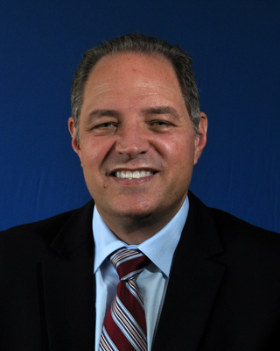

11:05-11:35am

**Jan van den Oetelaar, CEO, TASS International, a Siemens Business**

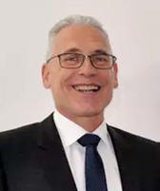

12:30-1:00pm

**Autonomous Vehicle LiDAR Thermal Design & Field Durability Prediction Solutions - Craig Hillman, DFR Solutions**

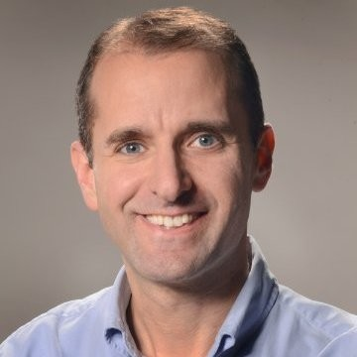

This presentation explores reliability and durability studies for important autonomous vehicle electronics sensors using virtual prediction using physics of failure methods, electronics cooling thermal simulation data, vibration analysis and other inputs for statistical system evaluation. These methods provide greater insight into how to improve product quality and reliability during design phases besides ensuring durability and safety throughout the product lifecycle with less required prototype testing.

1:00-1:30 pm

**How much testing is enough for Autonomous Vehicles? - Andrew Patterson, Mentor**

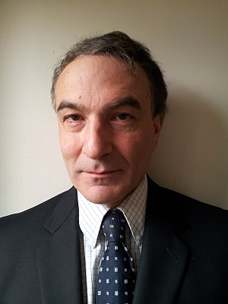

One of the biggest questions that has emerged with Autonomous Driving is how much testing is “enough” testing? Each mishap in these early stages of autonomous driving is very widely and disproportionately reported. Mentor announced the DRS360 AD platform last year for autonomous vehicle development, and this presentation looks at test scenarios for the platform using the TASS PreScan solution from Siemens PLM.

1:30-2:00pm

**Speaker TBD**

2:30-3:00pm

**Autonomous Drive – looking out 25 years! - Edward Bernardon Vice President, Strategic Automotive Initiatives at Siemens PLM Software.**



3:00-3:30pm

**Design-centric energy and thermal management in autonomous EV - Puneet Sinha, MAD Automotive Manager, Mentor**

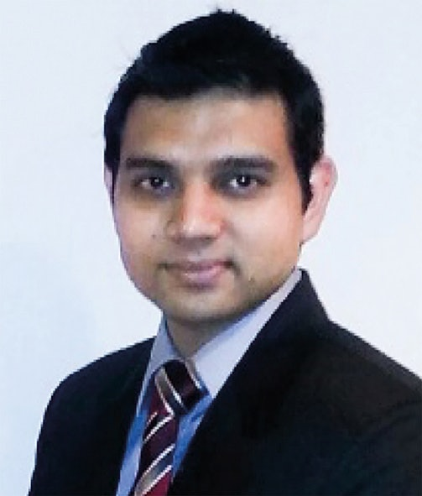

It is projected that by 2035, 25% of all cars will have partial or full autonomy by 2035. To deliver, the automotive supply chain will reshape very drastically in the coming years wherein necessary component-level technology (sensors/fusion box/new electronics) will be driven by the new entrants, but the responsibility of vehicle integration will continue to be with auto OEMs.

**Electrification Track**

10:35-11:05am

**Katrien Wyckaert, Director - Automotive Industry Solutions Simulation and Test Solutions, Siemens PLM Software**

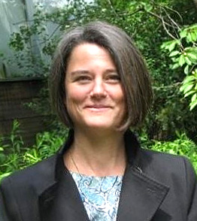

11:05-11:35am

**Electrification 2 – Guest Speaker TBD**

2:30-3:00 pm

**EV Thermal Management Systems & Range factors: Simulation Methods to Evaluate Designs - Doug Kolak, Mentor**

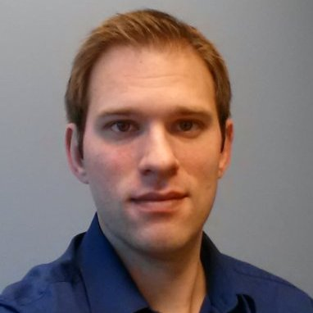

This presentation will review factors relating to vehicle range and vehicle thermal management systems design and operation.  Methods for evaluating vehicle thermal management system capability, efficiency and response are presented - inclusive of:  power electronics, motor and battery cooling; air conditioning and cabin comfort; other subsystems. A range of different useful operational performance evaluations, via transient simulations of drive cycle operation, will then be covered.

3:00-3:30 pm

**Autonomous, EV’s and how Capital accelerates E/E system development - Dan Scott, Mentor**

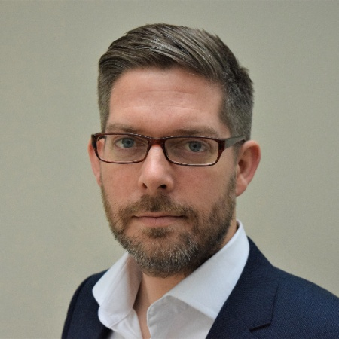

This session will address Automotive EE Design: autonomous, EV’s and the connected car. It will address how Capital can help automotive startups overcome the electrical systems engineering challenges associated with vehicle electrification and autonomy. Early-stage companies have unique challenges and Dan will share some of the common ones (and solutions!)

**Connectivity Track**

10:35-11:05am

**Connectivity Keynote - Michael Ziganek, Mentor**

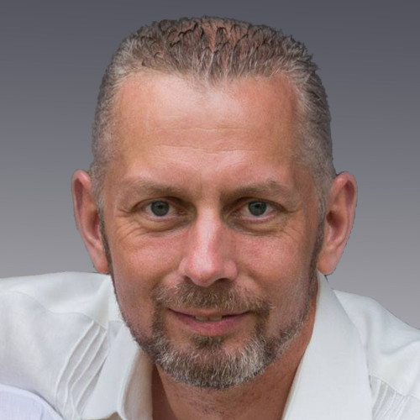

11:05-11:35am

**Android, QNX, Linux, Hypervisors and more! (or less?) - Roger C. Lanctot – Strategy Analytics, Director, Automotive**



Connected Mobility Seems like Android (P) is a BIG deal. QNX has peaked. Linux is peaking. Hypervisors (and cockpit domain controllers) are proliferating and Android is on everyone’s lips. Why? How? Impact? Safety relevance? Infotainment outlook? And where does mobility fit in?

2:30-3:00pm

**Tackling NVH issues with passive and active methods - Anil Khanna, Mentor**

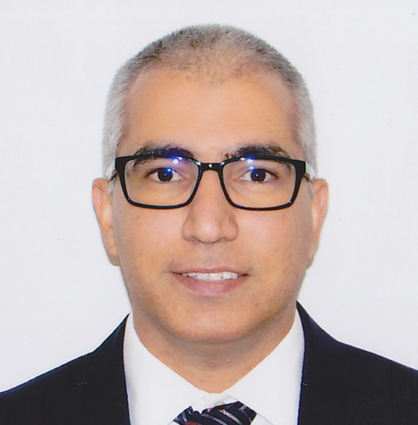

3:00-3:30pm

**Guest speaker- Siemens ITS**

**Architecture Track**

10:35-11:05am

**Systems engineering with Mentor’s Capital tools - Hans-Juergen Mantsch, Mentor**

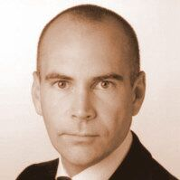

Mentor Electrification and Autonomous are the two key challenges for today’s Automotive industry. To design and implement the next generation products it is crucial to be able to create, validate and adopt efficient E/E Architectures. Still the industry suffers from outdated, disconnected flows and design methods which do not scale and cannot manage the inherited increase of complexity as well as the new functional safety demands

11:05-11:35am

**Yazaki Guest Speaker Ray Ernst, Head of Engineering, Yazaki**

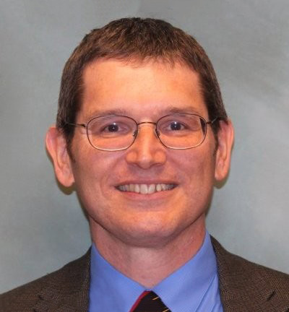

2:30-3:00pm

**Design Automation and Digital Continuity as Enabler for Functional Safety and Data Exchange - Sjon Moore, Technical Marketing Engineer, Mentor**

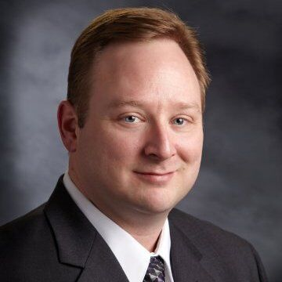

The first part of this session will talk about why it is so difficult to design electrical system, why sharing the work between OEMs and tier1s doesn’t make it easier and why functional safety will make things even more complicated. In the second part of this session we’ll look into how design automation and digital continuity can help to simplify this challenge.

3:00-3:30 pm

**Validating electrical designs with analysis - Nigel Hughes, Product Marketing Director, Mentor**

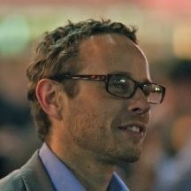

This session considers the typical methodology used to perform analysis of Electrical Distribution System (EDS) in modern platforms. We will explore the expected benefits of this analysis, and the reasons why the industry has typically failed to realize those benefits. We outline the Capital philosophy for analysis as part of a model-based engineering process, and how the challenges faced by the industry are addressed both in terms of process and the coming requirements.

**Solutions Breakouts**

**Management Track: Industry Trends & Challenges**

12:30-1:30pm

Panel Discussion: Disruptive Change - Moderator Nick Smith, Mentor

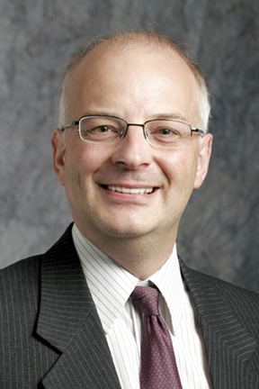

1:30-2:00pm

**Industry Trends & Challenges - Speaker TBD**

**Electrical Systems Design**

12:30-1:00pm

**The future of EDS design using the Capital generative Flow - Doug Hall, Mentor**



The automotive world is changing on an ever-increasing scale of complexity, from the number of features in a modern vehicle, to the number of configurations offered to the customer. Capital can manage the flow of data from global system designs through to localized platform architectures, and provide optimized harness derivatives based on marketing requirements that change daily. Capital also makes it easy to manage change at all points of the design flow, providing traceability with accurate, focused cost analysis, instilling confidence that changes can be made efficiently and effectively.

1:00 -1:30pm

**General Motors Guest Speaker**

1:30-2:00pm

**Using Capital for technical documentation and publishing - Muhammad Askar, Mentor**

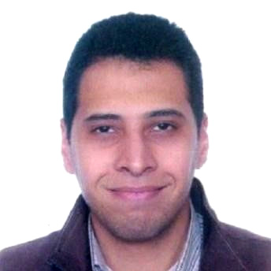

Technical documentation for electrical products are of high value for many teams throughout the extended enterprise. However, today’s processes are typically manual, labor-intensive and error-prone - often executed with dumb graphics package resulting in documentation that’s often too late, inaccurate and lacking in the interactivity that today’s stakeholders expect. The needs are most acute for after-sales troubleshooting where the need is for integrated diagnostics, wiring diagrams and 2 & 3D illustrations – and where a poor experience can impair the technicians’ efficiency, ultimately tarnishing the brand. Join us to discover how Capital Publisher empowers many teams in the extended organization through production of accurate, flexible, smart documentation woven together with 3D MCAD views for various needs: from design, to manufacturing, to service.

**PCB Systems Design**

12:30-1:00pm

**Multi-site Deployment of Xpedition Enterprise Data Management Travis Carter, GE Aviation and Ahsan Rahman, Mentor**



This presentation will review the deployment of a Multi-Site xDM server-based system for global application, presented by the customer and the Mentor integration team. The discussion will begin with the issues that drive the need for the xDM server and its capabilities. These should resonate with all involved in the ECAD – MCAD tools arena where library development, control and standardization is critical especially in a global integration development. During the introduction, a functional description of the xDM Server System will be reviewed in order to familiarize the audience with the toolset and review specific terminologies.

1:00 -1:30pm

**Product Development for EMC Compliance in the Automotive - Market Daren Shanholtzer, Manager, Harman International**

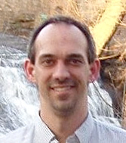

This presentation will highlight the use of tools like HLDRC, SI, and PI to expedite the engineering development timeline and reduce the chances of non-compliance.

1:30-2:00pm

**A Methodology and Design Flow for ISO 26262 PCB Design - Mike Varnau, President, Varnau-Mack Engineering**

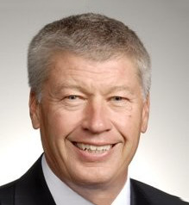

The ISO 26262 specification is focused on the safety of the operator, passengers and service personnel of automotive vehicles. The specification covers the entire product life cycle of management, development, production, operation, service and decommissioning. ISO 26262 categorizes the safety risk of a design by the use of Automotive Safety Integrity Levels (ASIL) of QM, A, B, C and D. It is imperative that the electronic PCB design tools be capable of tracking the implementation of the product requirements and meeting the expected level of analysis, performance and integrity for the specified ASIL requirements of that portion of the design. This paper will present a design process/flow that focuses on the development and production aspects of the ISO 26262 specification

**Wire Harness Engineering**

12:30-1:00pm

**Capital and Industry 4.0 - Alejandro Cid, LEONI**

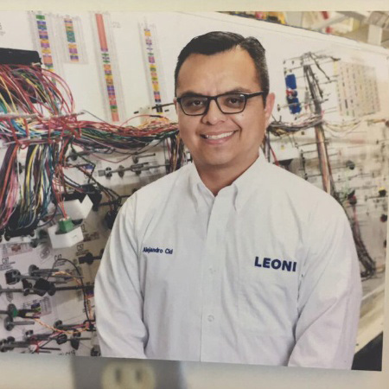

This session will cover three key areas:

• Capabilities of Capital XC as a core tool for industrialization

• Challenges of the next generation of harness manufacturing processes

• Integration of capital XC to next generation of manufacturing Industry

1:00-1:30pm

**Model-based manufacturing for the wire harness industry - John Judkins, Technical Director, Mentor**

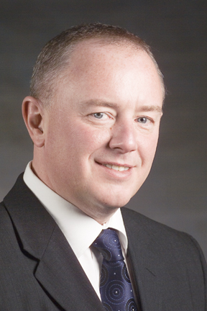

1:30-2:00pm

**Guest speaker: Lear**

**Automotive IC Design**

12:30-1:00pm

**Pre Silicon Autonomous Validation Environment - David Fritz, Mentor**

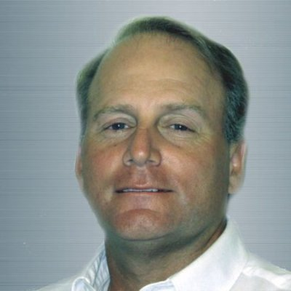

1:00-1:30pm

**Automotive Test Solutions for ICs - Steve Pateras, Mentor**

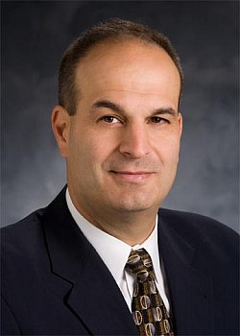

1:30-2:00pm

**Bryan Ramirez, Mentor**



**Functional Safety/ ISO 26262**

12:30-1:00pm

**SOTIF and the Systems Engineering Pipeline - Kyle Post, Senior Systems Engineer, Ford**

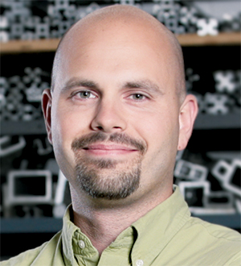

1:00-1:30pm

**Intelligent Data Integration for your Functional Safety reduces e­ffort and cost - Kareem Al-Senan, Mentor**

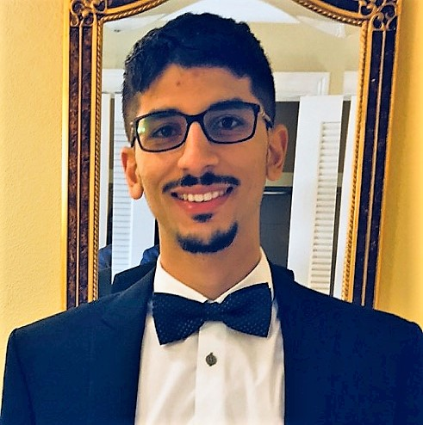

Accessing the right information at the right time to enable informed decisions can seem impossible. A solution that can access federated data and provide knowledge about dependencies and impacts in a changing flow as they happen provides individual stakeholders with relevant information with just a simple query. This presentations shows how to leverage the flexibility and vendor-agnostic linked data model of Context SDM with the power of Team center PLM.

1:30-2:00pm

**How to cut cost & simplify Functional requirements for all Automotive Safety Integrity Levels - Joe Dailey, Mentor**

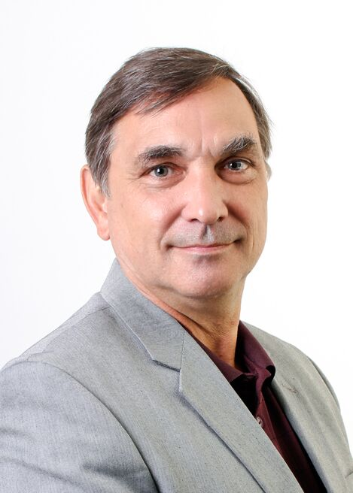

**Thermal and CFD**

12:30-1:00pm

**Guest Speaker TBD**

1:00-1:30pm

**Thermal Design of Autonomous Vehicle Sensors & Electronics - Adil Ali, Mentor**

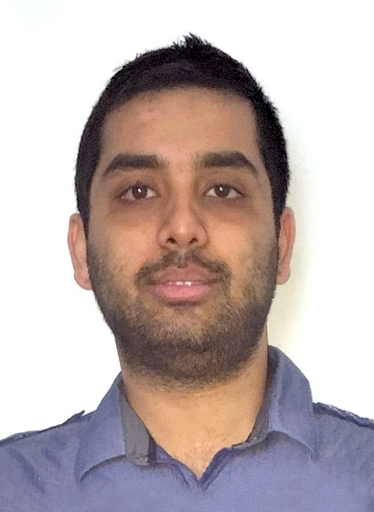

Autonomous vehicles rely on accuracy and reliable performance of sensors and onboard processing hardware.  Low power sensors can experience challenging thermal issues depending on mounting location and harsh environment factors; High power sensor fusion systems often have high heat dissipation requirements and face constraints from packaging and vehicle integration.  This presentation explores thermal design of sensors and data processing modules using simulation tools to evaluate sealed electronics systems, understand operational scenarios and factors such as external solar heat loading, through to optimizing forced convection or liquid cooling for efficient operation of processing modules.

1:30-2:00pm

**Power Electronics Thermal Design: IGBT Testing & Improving Inverter Level Simulation - Prasad Tota, Mentor**

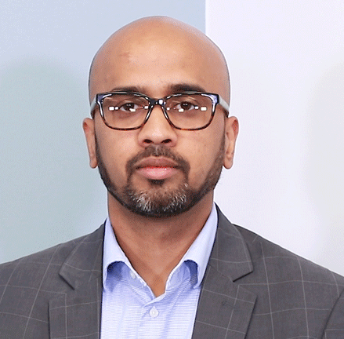

For compact design of power electronics modules, thermal management at component to module level must be evaluated for optimal performance and reliability. This presentation introduces a study of multiple thermal measurements of IGBT power semiconductors within an inverter, followed by calibration of detailed compact thermal models for use in improving the system level electronic cooling simulation accuracy of the module.  This approach combines use of MicReD T3Ster thermal transient measurement technology for heat flow path analysis of power semiconductors and automatic detailed package model calibration and system simulation possible with FloTHERM software.

**Networking, AUTOSAR and Ethernet**

12:30-1:00pm

**AUTOSAR Platforms– Standardizing a SW System framework for autonomous and connected vehicles - Rick Flores, GM Technical Fellow and AUTOSAR Chairman  
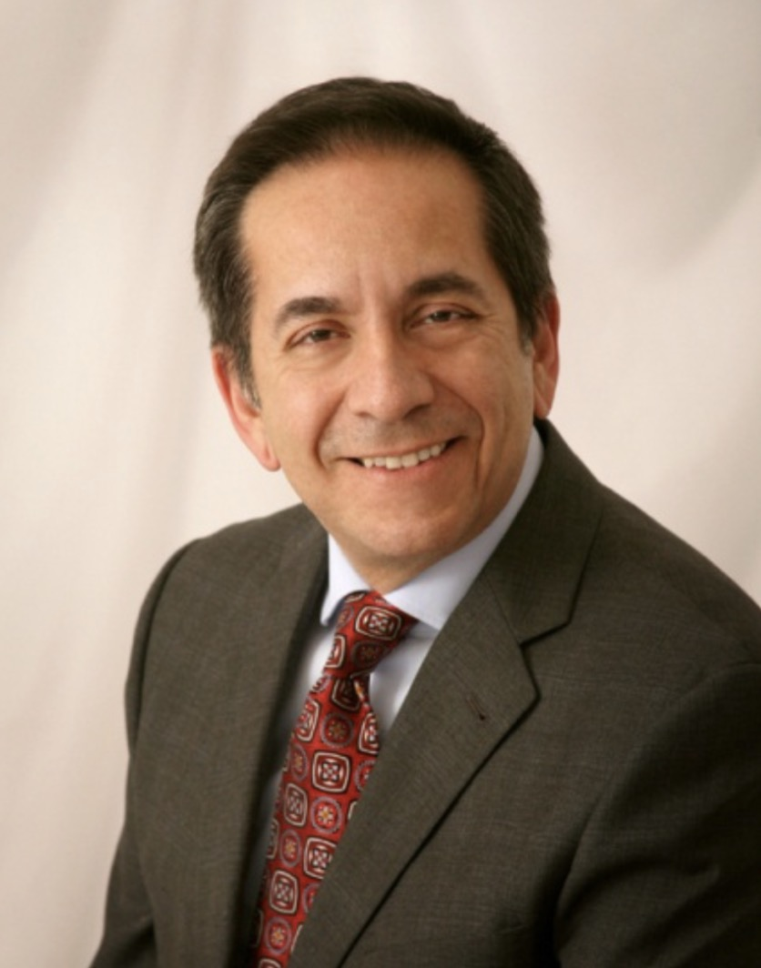**

1:00-1:30pm

**Addressing in-vehicular bandwidth requirements - Ahmed Majeed Khan, Staff Engineer, Mentor and Mathias Fritzson, AES Product Manager, Mentor**

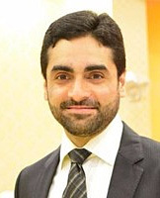

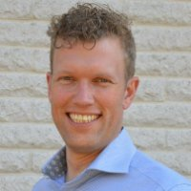

The session will have following parts:

• Explanation of diagnostics according to ISO 15118, ISO 13400 and AUTOSAR Diagnostics over IP (DoIP) specification along with their implementation on an Ethernet infrastructure

• Elaboration that these routing schemes cover Ethernet/DoIP to non-DoIP (CAN, Lin, FR) ECU gateway, but fail to address Ethernet/DoIP to Ethernet/DoIP ECU diagnostic message routing. And thus, in its current form, the use-cases of in-vehicular Ethernet nodes has not been standardized.

• Proposal with novel enhancements to existing vehicular communication networks so it can handle the tester-ECU and inter-ECU network design for Ethernet/DoIP to Ethernet/DoIP ECU communication.

• A tool flow to demonstrate automotive electrical design with complete systems engineering approach to address this use-case:

• Capital (electrical wire harness design) -> VSA-COM (electrical network design) ->VSB (configuration of the network for proposed approach) ->VSTAR Embedded SW (automotive software with gateway and diagnostics support)

1:30-2:00pm

**AUTOSAR software configuration driven from E/E Design - Brendan Morris, Mentor**

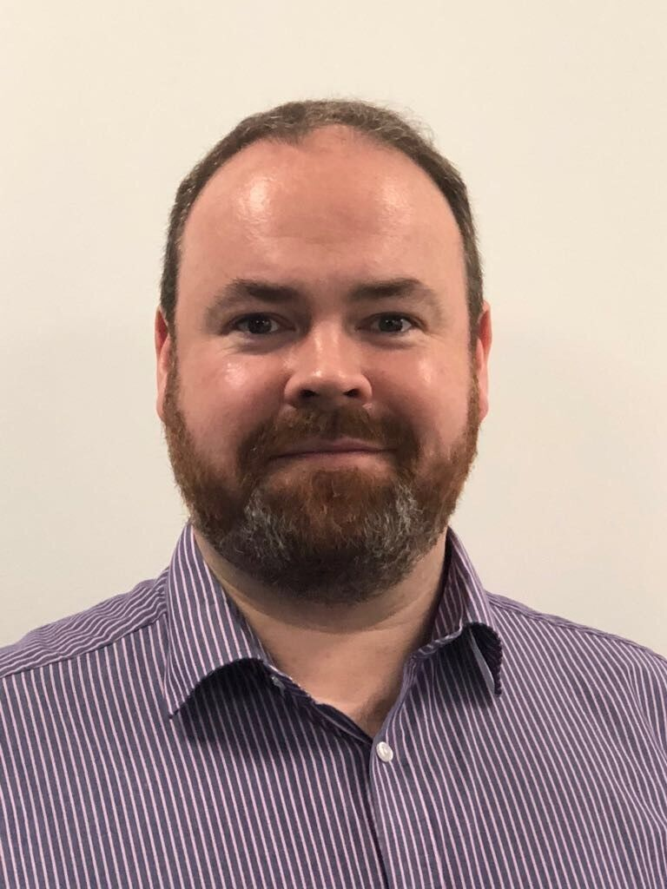

System Driven Product Design: System complexity in Vehicle Platform E/E Architectures is continuously increasing contributed to by the Megatrends of Automation and Connectivity. Ensuring that the vehicle systems will perform as intended can be a very complicated task. This session demonstrates how designing and optimizing the Platform Architecture can drive configuration of all of the interacting parts of the system using Mentor’s Capital and Volcano tools, ensuring consistent network communication, and software behavior across the complete system. Orchestrated by Teamcenter or Polarion, and supplying Embedded Software Designer with configuration supporting a fully documented, traceable, Correct by Construction flow.